1.24 Xpath and Compare Assertion

This section will guide you to understand:

* How to add Xpath assertion
* How to add compare assertion

**Development Environment:**

* Apache JMeter 5.1.1 Version

This guide has three subsections, namely:

1.24.1 Adding Xpath assertion

1.24.2 Adding compare assertion

1.24.3 Pushing the code to GitHub repositories

**Step 1.24.1**: Adding Xpath assertion

The Xpath assertion is used to validate the response using Xpath expressions. Steps to add Xpath assertion in JMeter are shown below:

* Open the Apache JMeter.
* Click on the Test Plan.
* Rename the Test Plan.
* Right click on Test Plan --->Add--->Thread(users)--->Thread Group.

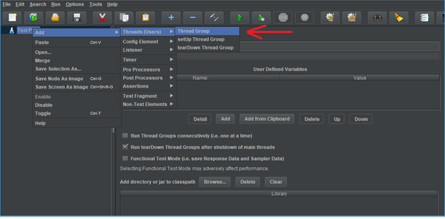

* Go to Thread Group--->Name--->Comments---> Continue --->Thread Properties--->Number of Threads(users): ---> Ramp-Up Period (in seconds): ---> Loop Count --->Save.

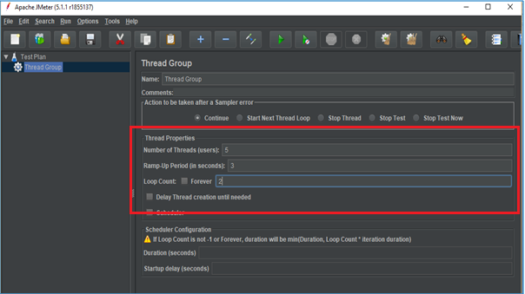

* Right click on Thread Group --->Add---> Sampler---> HTTP Request.

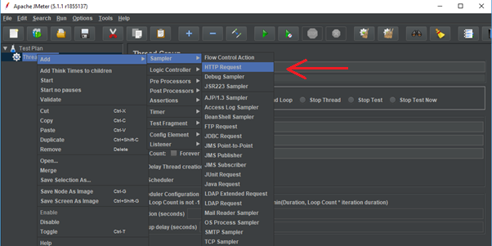

* HTTP Request---> Server Name or IP :---> Path :/---> Save.

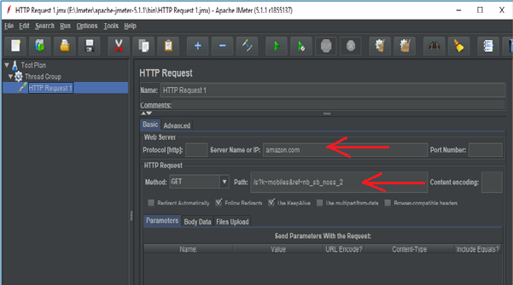

* Right click on Thread Group --->Add--->Listeners---> View Results Tree---> Run.

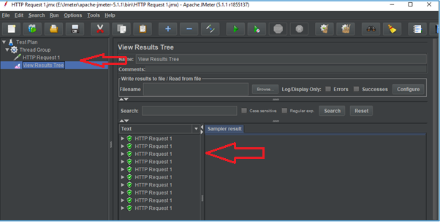

* Right click on Thread Group --->Add--->Listeners---> View Results in Table---> Clear All---> Save---> Run.

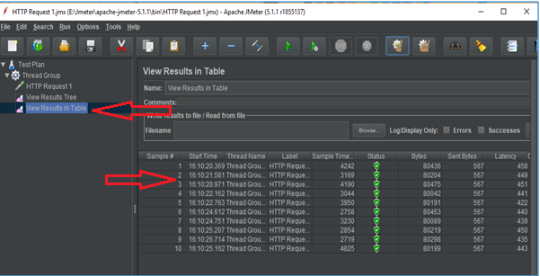

* Right click on Thread Group --->Add--->Listeners---> Assertions Results---> Clear All---> Save---> Run.

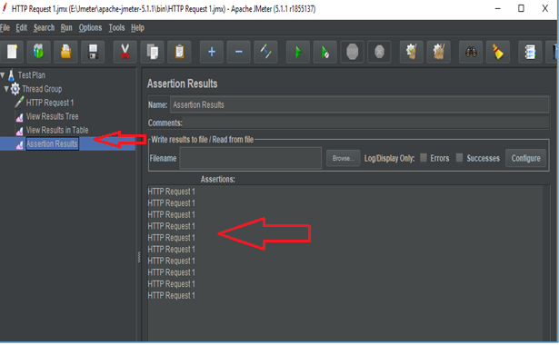

* Right click on Thread Group --->Add--->Assertions ---> Xpath Assertions---> Main sample only---> Quiet --->Xpath--->//*[@id=”search-2”]/format/input--->Save.

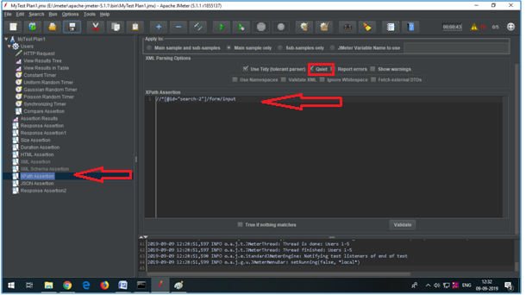

* Go to Assertion Result---> Run. This will show an error.

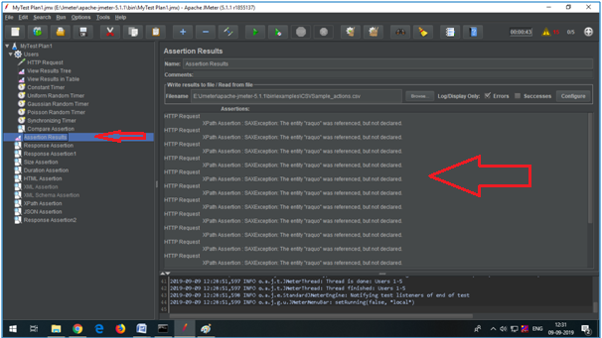

* Right click on Thread Group --->Add--->Assertions ---> Xpath Assertions---> Main sample only--->Use tidy(tolerant parser)---> Quiet --->Xpath--->//*[@id=”search-2”]/format/input--->Save.

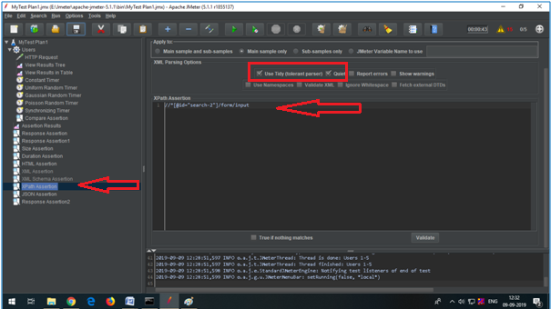

* Click on Clear All---> Run--->View Results in Table.

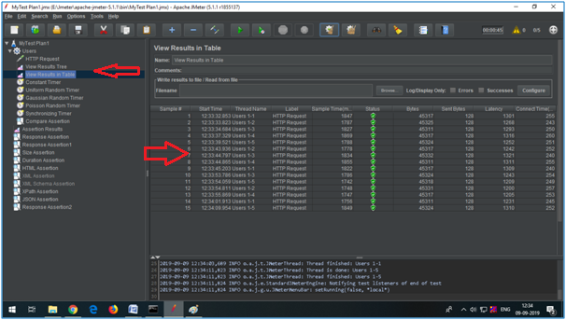

**Step 1.24.2:** Adding compare assertion

The compare assertion checks the response content or confirms that response time of all samplers under the assertion scope are equal.

The request and the assertion should be on the same level in the test plan. Steps to add Xpath assertion is given below:

* Open the Apache JMeter.
* Click on the Test Plan.
* Rename the Test Plan.
* Right click on Test Plan --->Add--->Thread(users)--->Thread Group.
* Right click on Thread Group --->Add--->Assertions ---> Compare Assertions---> Compare Content---> Compare Time.

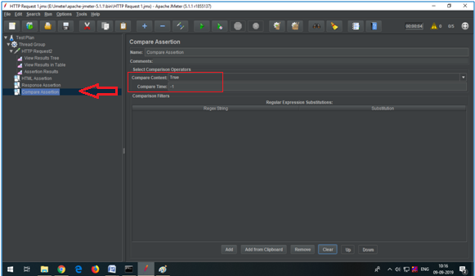

* Right click on View Results in Table---> Run.

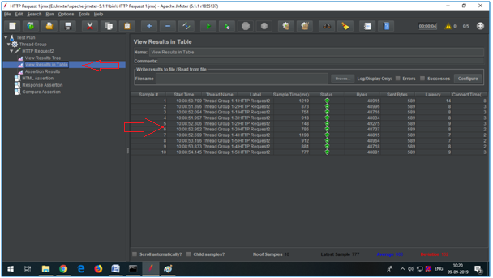

**Step 1.24.3**: Pushing the code to GitHub repositories

Open your command prompt and navigate to the folder where you have created your files.

cd <folder path>

Initialize your repository using the following command:

git init

Add all the files to your git repository using the following command:

git add . 

Commit the changes using the following command:

git commit . -m “Changes have been committed.”

Push the files to the folder you initially created using the following command:

git push -u origin master